RIGHTS HERE. RIGHTS NOW.
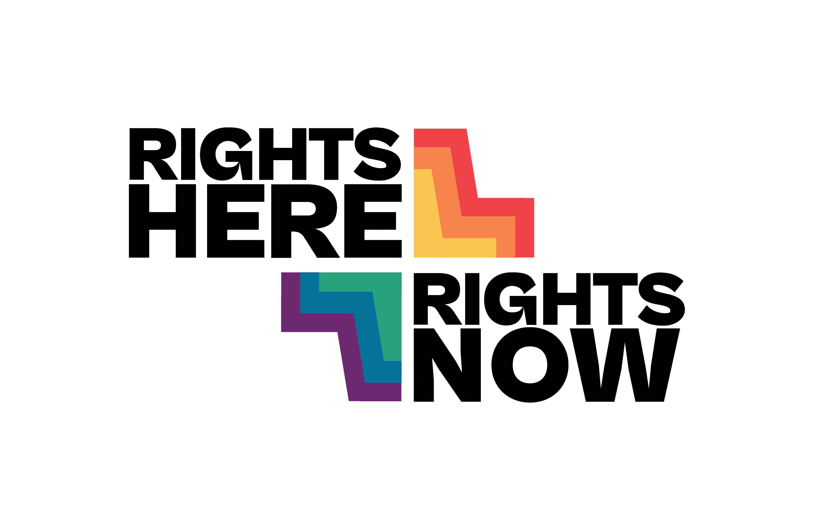
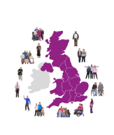 | Human rights are important for everyone. This campaign shares stories from people across Scotland.

What are human rights?

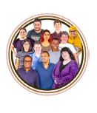 | Human rights are rights and freedoms we all have. Human rights help people live safely, fairly and with dignity.

Human rights affect everyday life

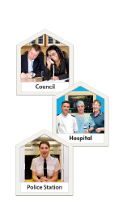 | Human rights affect where we live, our health, our education and our family life.

Real stories matter

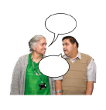 | People across Scotland have shared their stories. These stories show how human rights affect people's lives.

The stories are about

 | Housing, disability rights, healthcare, education, access to justice and the environment.

Human rights are for everyone

 | Human rights are not special treatment. Human rights help protect everyone.

What does the campaign want?

 | More people to understand human rights and stronger protection for rights in Scotland.

How can you help?

 | Share campaign stories, talk about human rights and tell other people about the campaign.

Be respectful

 | Please respect people's privacy and share stories in a respectful way.

Your voice matters

 | Human rights matter to everyone in Scotland.

Find out more

 | Visit the campaign website and follow the campaign on social media.

 | 

